- PURPOSE

  - This Advisory Circular provides direction and guidance to the Operator on the methods for surveillance as required by the Civil Aviation Regulations. For purposes of this Circular, the term Operator means approval, certificate and licence holders.

  - For an Operator to be certified or have his Certificate renewed, the Civil Aviation Authority (CAA) must be satisfied that the Operator is capable of fulfilling the required certification requirements, and complies with the Regulations in an appropriate and continuous manner. The Operator must therefore be prepared to undergo a CAA surveillance audit in order to ensure that he meets/continues to meet certification requirements.

- REFERENCES

  - The Civil Aviation Act;

  - The Civil Aviation (Air Operator Certification and Administration) Regulations, as amended;
  - The Civil Aviation (Operation of Aircraft - Commercial Air Transport) Regulations, 2024
  - The Civil Aviation (Operation of Aircraft - General Aviation) Regulations, 2024
  - The Civil Aviation (Operation of Aircraft - Helicopter Operations) Regulations, 2024 as amended;
- SURVEILLANCE OF OPERATORS

3.1 The surveillance process described herein is both for ensuring that the Operator complies with the Regulations in an appropriate and continuous manner, and also for an applicant seeking issuance/renewal of an approval, certificate or licence.

3.2 It is important for the Operator to understand the clear distinction between surveillance and certification activities. Both are important aspects for the compliance of Regulations and Quality Control. One should not take precedence over the other. Certification activities are required in order to be licensed, certificated, or otherwise approved to carry out certain functions. Surveillance, on the other hand, is aimed at ensuring that the administration, facilities or equipment continue to adhere to the standards by which they were certificated or approved, through regular inspections of various aspects of their operations.

- GENERAL SURVEILLANCE GUIDELINES

  - Communication of Intent to Inspect a Facility or Organisation:

4.2 Inspectors will contact the Operator in advance where necessary to make appropriate arrangements for inspecting or carrying out surveillance.

4.3 Where such advance notice has been made, the Operator will be briefed in detail regarding the specific intent of the inspection, the areas to be covered, and the approximate duration of the inspection. Arrangements should be made by the Operator to ensure that key company personnel will be present during the course of the inspections to provide information and answer questions. The required Operator personnel presence will vary according to the type of inspection. For example, when evaluating Operational Control procedures and operations, the Inspector will require almost constant contact with personnel who are responsible for each functional area. In contrast, the inspection of Flight and Duty Time records requires very little company personnel involvement except to make records available and answer any initial questions the Inspector may have about the record keeping system.

Note: for continuous surveillance inspections e.g. ramp spot checks, the Operator need not be notified.

  - Presentation of Credentials

    - Upon arriving at the site where the inspection is to be conducted, the CAA Inspectors shall introduce themselves and present their identification to the Operator.

    - The Inspector(s) shall review with the Operator the scope of the inspection to be conducted, and assemble key organisation personnel who are to be available to answer questions during the course of the inspection.

    - After the inspection, the Inspector(s) shall inform the Operator of the findings as appropriate.

- EVALUATION OF REPORTS

The Operators shall avail the Inspector with Reports from the Reliability Programmes, FDR and CVR recordings and calibration for evaluation. Analysis of the data from the Reports shall provide the Inspector with the basis of his next course of action.

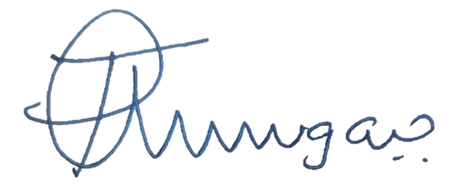

______________________
Director Safety Regulation

